CI-01 Interline transfers of live animals shipments are not accepted, except for dogs and cats.

CI-02 All poisonous reptiles (snakes and lizards) and insects (e.g. spiders, scorpions) will not be accepted for carriage on passenger flight.

CI-03 Non-human primates will not be accepted for carriage.

CI-04 The following fighting breeds of dogs will not be accepted for carriage.
 American Pit Bull
 American Staffordshire Terrier
 Fila Brazileiros
 Japanese Tosa
 Pit Bull Terreir
 Toga Argentinos

CI-05 The following snub nosed dogs and cats will only be accepted for carriage when total journey time does not exceed 6 hours (total flying and ground time at intermediate point) and the temperature on any portion of their journey will not exceed 21°C (70°F).
Snub nosed dogs:
 Boston Terrier
 Boxer
 Brussels Griffin
 Bull Terreir
 Chinese Pug
 Dutch Pug
 English Bulldogs
 English Toy Spaniel
 French Bulldogs
 Japanese Chin
 Japanese Pug
 Lhasa Apso
 Pekinese
 Shih Tzu
 Tibetan Spaniel
Snub nose cats
 Burmese
 Exotic
 Himalayans
 Persians

Special precautions are required, because these breeds are susceptible to increased risk of heat stroke and breathing problems when exposed to stress or extreme heat.
China Airlines requires the following when shipping or handling these breeds:
 1 size larger kennel than is normally required. The kennel must have ventilation on 4 sides.
 Customers are advised to acclimate the animal to the kennel by letting the animal spend time in the kennel for several days before their departure.
 No food in the kennel during the flight, just water.

CI-06 Puppies and kittens under 10 weeks old will not be accepted for carriage.

CI-07 Strongly smelling animals will not be accepted for carriage on passenger aircraft.

CI-08 Live animal originating in tropical regions, e.g. live tropical fish, birds, as well as cold blooded animals (e.g. snake, frog) will not be accepted for carriage if the temperature on any portion of their journey is 10°C (50°F) or lower.

CI-09 B738 cargo holds are not permitted to carry live animals, except for those animals, such as tropical fish, eels, crustaceans which do not require ventilation or high temperature.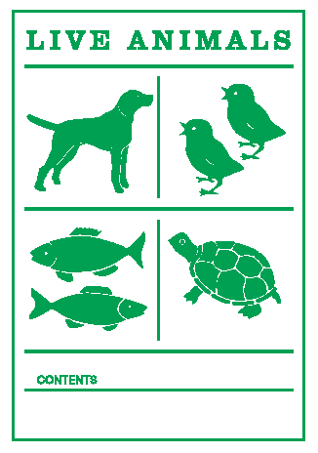
FZ-5037
F-FZ060A

